System installation guide
1. Install MySQL, PyCharm, and VSCode.
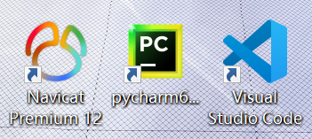
2. Start the MySQL service.
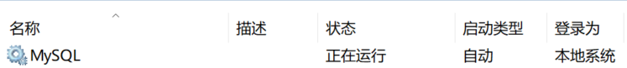
3. In PyCharm, open the project file, select the admin directory, select "manage," and then click the green arrow button on the right to start it. See the image below.
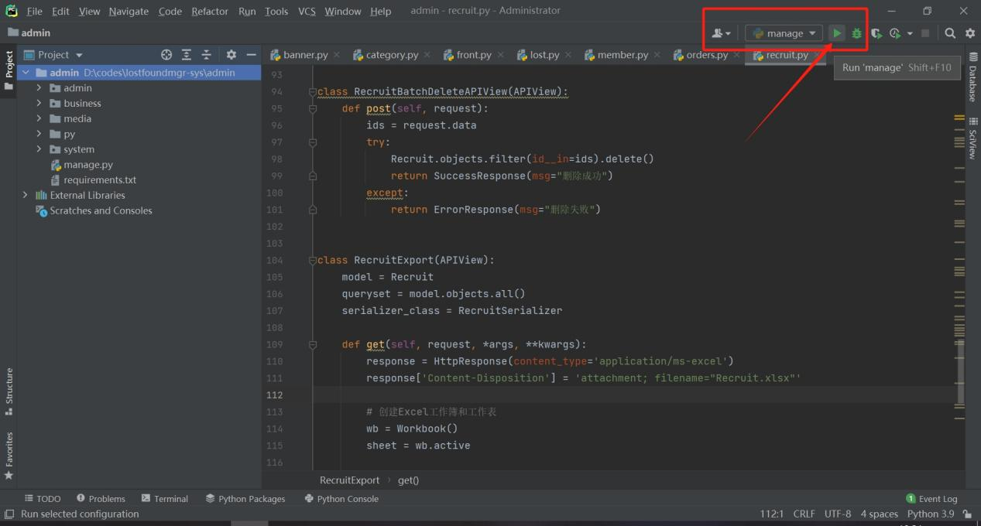
After successful startup, the IP address and port will appear at the bottom of the screen, indicating that the Python backend program has started. See the image below.
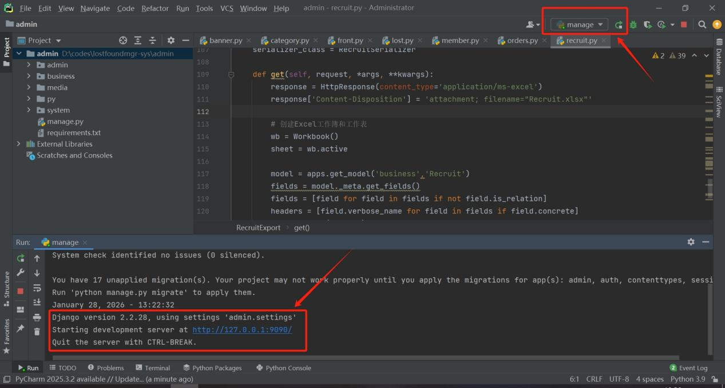
4. In VSCode, open the front directory, double-click the package.json menu, find "dev" in the code instructions area on the right, and click "Run Script" to run the project backend program. See the image below.
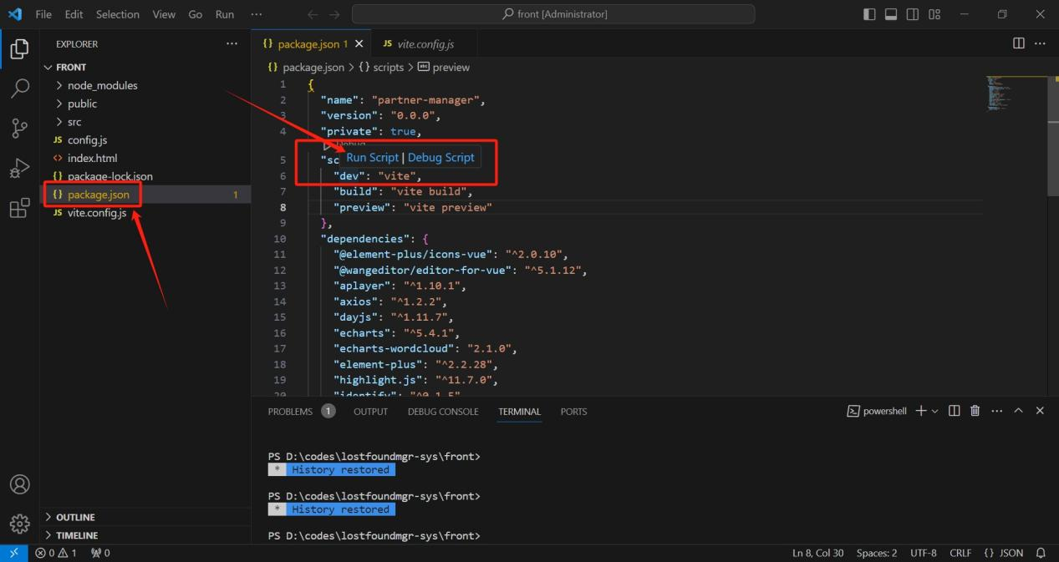
5. After successful execution, a list of system addresses will pop up in the terminal window at the bottom. Select any address to follow the link or copy the URL into your browser to log in to the system homepage. See the image below.
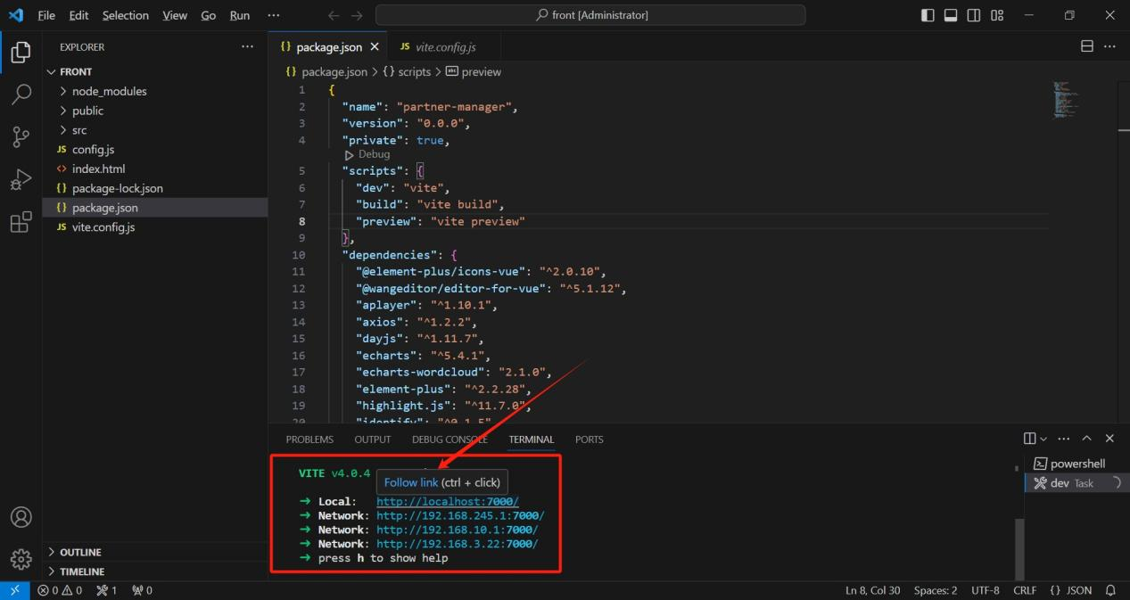
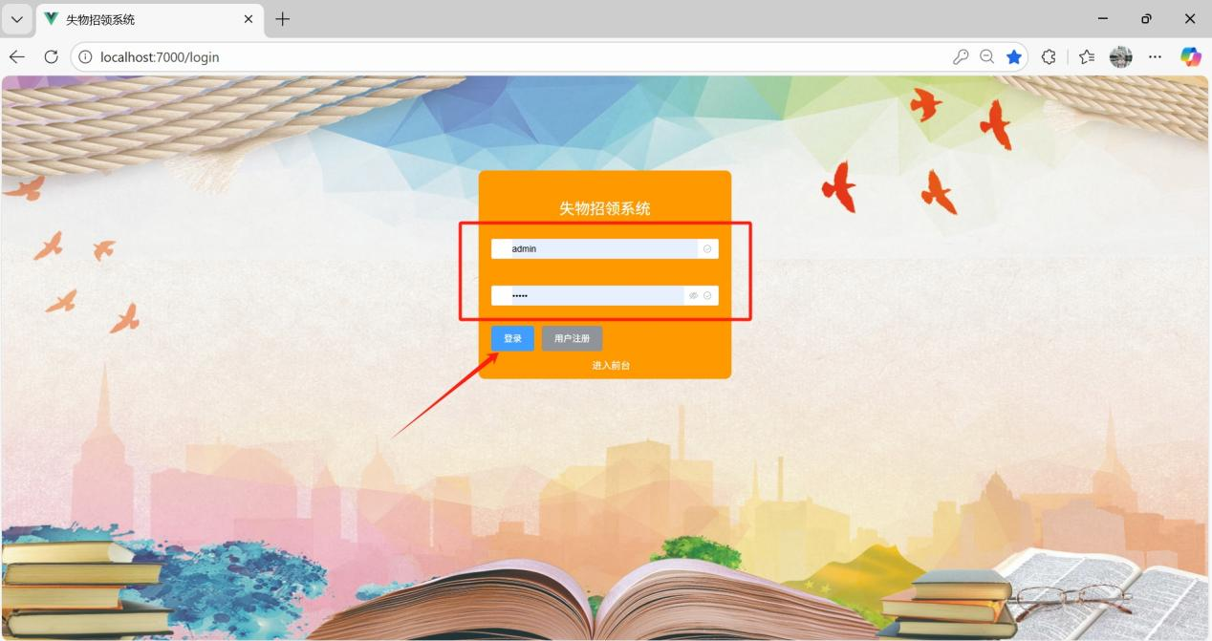
6. Administrator account: admin, password: admin.

